Semester Two Examination 2019

Question/Answer Booklet

Psychology Unit 1 and 2

Student Number: In figures

In words _________________________________

Student Name _________________________________

Time allowed for this paper

Number of additional answer booklets used (if applicable):

Reading time before commencing work: ten minutes

Working time: three hours

Materials required/recommended for this paper

*To be provided by the supervisor*

This Question/Answer booklet

*To be provided by the candidate*

Standard items: pens (blue/black preferred), pencils (including coloured), sharpener, correction fluid/tape, eraser, ruler, highlighters

Special items: non-programmable calculators approved for use in this examination

Important note to candidates

No other items may be taken into the examination room. It is **your** responsibility to ensure that you do not have any unauthorised material. If you have any unauthorised material with you, hand it to the supervisor **before** reading any further.

Copyright © Academic Associates 2019.

Structure of this paper

|  |  |  |  |  |  |
| --- | --- | --- | --- | --- | --- |
| Section | Number of  questions available | Number of questions to  be answered | Suggested working time (minutes) | Marks available | Percentage  of  examination |
| Section One  Research methods | 3 | 3 | 30 | 35 | 20 |
| Section Two  Short answer | 6 | 6 | 90 | 99 | 55 |
| Section Three  Extended answer | 2 | 2 | 60 | 50 | 25 |
|  |  |  |  | **Total** | 100 |

**Instructions to candidates**

1. The rules for the conduct of the Western Australian external examinations are detailed in

the *Year 11 Information Handbook 2019*. Sitting this examination implies that you agree

to abide by these rules.

1. Write your answers in this Question/Answer booklet preferably using a blue/black pen.

Do not use erasable or gel pens.

1. Answer the questions according to the following instructions.

Sections One and Two: Write your answers in this Question/Answer booklet. Wherever possible, confine your answer to the line spaces provided.

Section Three: Consists of two questions. You must answer both questions.

1. You must be careful to confine your answers to the specific questions asked and to follow

any instructions that are specific to a particular question.

1. Supplementary pages for planning/continuing your answers to questions are provided at

the end of this Question/Answer booklet. If you use these pages to continue an answer,

indicate at the original answer where the answer is continued, i.e. give the page number.

|  |  |
| --- | --- |
| Section One: Research methods | 20% (35 Marks) |

This section has **three** questions. Answer **all** questions. Write your answers in the spaces

provided.

Supplementary pages for planning/continuing your answers to questions are provided at the end of this Question/Answer booklet. If you use these pages to continue an answer, indicate at the original answer where the answer is continued, i.e. give the page number.

Suggested working time: 30 minutes.

_____________________________________________________________________________

**Question 1 (8 marks)**

Alana was interested in seeing whether there was a link between Star Wars fans and having red hair. She attended the premier of the newest Star Wars movie in 15 different cinemas and recorded the number of attendees and the number of red heads and graphed the information below.

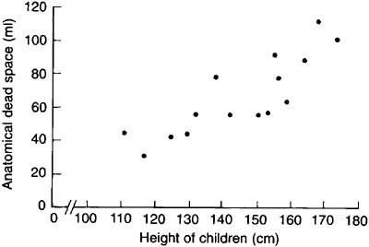

No. of Attendees

No. of Redheads

1. Name the type of study Alana conducted. (1 mark)

1. Is this an experimental or non-experimental method of study? Explain your response. (2 marks)

1. What conclusion could Alana draw from her research? (2 marks)

**Question 1** (continued)

Alana then asked random attendees at the premier to explain three reasons they thought Star Wars was good and recorded their answers.

1. What type of data was Alana collecting? (1 mark)

1. List **one** advantage and **one** disadvantage to collecting this type of data. (2 marks)

Advantage:

Disadvantage:

**Question 2** **(19 marks)**

Dr Ackland and his team wanted to find whether taking two caffeine capsules every morning increased work productivity in 25-35 year old accountants.

1. Identify the **seven** steps of the scientific method Dr Ackland would have to follow.

(7 marks)

One:

Two:

Three:

Four:

Five:

Six:

Seven:

Dr Ackland’s team approached 50 accounting firms in Perth CBD, asking for volunteers aged 25-35 to take part in the study. He took the first 60 people who expressed interest in participating and divided them into two groups. Group A were told to take two caffeine tablets every morning before 9am while Group B were told to take two tablets (they believed were caffeine tablets) every morning before 9am. Their productivity was measured by the number of completed files each day.

1. Group B were given a placebo, what is the purpose of using a placebo in an experiment? (2 marks)

**Question 2** (continued)

Dr Ackland used a double-blind procedure. This is where both the participants and the person administering the capsules are not aware which group is receiving the real capsules and which are receiving the placebo.

1. Why might researchers use double-blind procedures in some experiments? (1 mark)

1. Discuss **two** ethical considerations Dr Ackland needs to consider when conducting this experiment. (6 marks)

one:

two:

In Dr Ackalnd’s study, he found that there was a significant increase in performance from Group A, and only a very small increase in Group B.

1. For Dr Ackland to be able to draw conclusions from the data for the population, he must ensure there are no sources of error. List **three** potential sources of error. (3 marks)

one:

two:

three:

**Question 3 (8 marks)**

1. Explain the term uncontrolled variables in regard to psychological research. (1 mark)

1. Name and describe **two** types of reliability. (4 marks)

one:

two:

1. In psychological research, one can never say that a hypothesis is proven correct, only that it is supported. Why is this? (3 marks)

**End of Section One**

|  |  |
| --- | --- |
| **Section Two: Short answer** | **55% (99 Marks)** |

This section has **six** questions. Answer **all** questions. Write your answers in the spaces

provided.

Supplementary pages for planning/continuing your answers to questions are provided at the end of this Question/Answer booklet. If you use these pages to continue an answer, indicate at the original answer where the answer is continued, i.e. give the page number.

Suggested working time: 90 minutes.

_____________________________________________________________________________

**Question 4 (15 marks)**

1. Define the term recreational drug. (1 mark)

Disinhibition is a lack of restraint manifested in disregard of social conventions, impulsivity and poor risk assessment.

1. Explain why disinhibition is relevant to studies on drugs. (2 marks)

Addi was at a party with some friends when she decided to partake in recreational drug use (which was a very bad idea). Her friends noticed she started to act differently, jerky movements, overexcitable discussion and that her pupils were larger than normal.

1. What is the most likely classification of drug Addi took at the party? (1 mark)

1. Explain the evidence from the scenario that leads to this conclusion. (3 marks)

Addi’s friends were concerned about her taking the drug, in particular the more long-term impacts that the drug use could have on Addi.

1. Give **two** psychological and **two** physiological long-term effects that could result from the drug Addi took at the party. (4 marks)

Psychological:

Physiological:

1. Addi enjoys running most mornings. She believes it increases her mood. Explain why this might be correct. (1 mark)

Addi started running after learning about the positive effects of exercise in Psychology class.

1. State **one** positive effect each that exercise has on behaviour, emotion and thoughts. (3 marks)

Behaviour:

Emotion:

Thought:

**Question 5 (15 marks)**

Alvin’s teacher suggested his parents look into Alvin’s intelligence levels after it was found he differed quite a lot from his peers. Testing suggested that, at age 14, he had a mental age of 20.

1. What is Alvin’s IQ using concepts devised by Terman? (1 mark)

1. Alvin’s mother, Alma (who is 48), was interested in her own IQ and asked to be tested also. She was told that the same testing would not give her an accurate score. Why is this? (2 marks)

1. Name the theorist whose work could be used to better test Alma. (1 mark)

1. Explain why these tests are more accurate with adults and more commonly used now. (1 mark)

1. Alma also looked at Alvin’s emotional quotient. Define this term. (2 marks)

Alvin was also being assessed by his psychiatrist, who wanted to look at the different states of consciousness Alvin experienced during an average night.

1. Name and explain **two** physiological responses the psychiatrist could use to assess Alvin. (4 marks)

One:

Two:

1. When looking at Alvin’s brain waves, suggest **two** changes to Alvin’s brain wave patterns his psychiatrist would be looking for. Name and describe both properties. (4 marks)

One:

Two:

**Question 6 (19 marks)**

1. Name and define the **three** levels of peer groups in adolescence. (6 marks)

One:

Two:

Three:

1. Name the type of research pioneered by Dexter Dunphy. (1 mark)

At school, Agatha has a small group of girlfriends, they call themselves the Strangerdale Girls as they all love Stranger Things and Riverdale. Each Friday, they have a $5 “lucky dip” with the group. One of the girls has recently started dating Anthony, a boy from school.

1. Based on Dunphy’s theory, what stage of adolescent group structure is Agatha currently in? (1 mark)

1. Explain what will happen for Agatha and her friends in the next stage. (2 marks)

1. Name, explain and give an example using the Strangerdale Girls, of each of the **three** determinants of liking in the table below: (9 marks)

**One mark per correct box**

|  |  |  |
| --- | --- | --- |
| **Name** | **Explanation** | **Example** |
|  |  |  |
|  |  |  |
|  |  |  |

**Question 7 (14 marks)**

1. Define human development. (2 marks)

1. Psychologists often talk about the nature/nurture debate. Explain the **two** sides to this discussion. (2 marks)

1. Ahmed is a dizygotic twin. What does this mean about his shared DNA in comparison to other types of twins or siblings? (2 marks)

1. Briefly explain how dizygotic twins are conceived in the womb. (2 marks)

Ahmed and Archer enjoy playing at day care. They often choose to play with cars, each driving them around the room, on the walls and up table legs. One day, Archer drives the car up his own leg and then makes it do a flip onto the table, Ahmed watches and does the same thing. The boys seem lost in their own little worlds playing with their cars.

1. Which category of play is it likely the boys are currently interacting in? Give **one** reason for your answer. (2 marks)

1. In what way does play assist in the physical and social development of children?

(4 marks)

**Question 8 (17 marks)**

1. Define personality. (1 mark)

1. What is the name of the personality theory coined by Freud? (1 mark)

1. Divide and label the **three** components of Freud’s “iceberg” theory of personality as well as the **two** levels above and below the “water”. (6 marks)

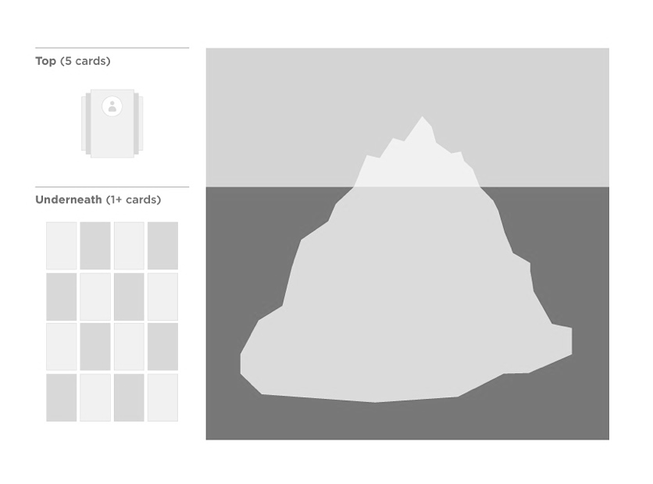

1. Explain the conflict Freud saw as needing to be resolved which determines one’s personality. (3 marks)

1. Name and explain **three** defence mechanisms proposed by Freud. (6 marks)

One:

Two:

Three:

**Question 9 (19 marks)**

1. Define prejudice. (1 mark)

1. Prejudice usually involves three components. Name these **three** components. (3 marks)

One:

Two:

Three:

1. Name and explain **two** causes of prejudice. (4 marks)

One:

Two:

Ava was quite racist when it came to people from Austria. When an Austrian girl moved to her school, she was hesitant to try to get to know her. The girl joined Ava’s book club at school and then started swimming lessons alongside Ava out of school. As Ava got to know her, she realised the girl was very similar to herself and was actually quite lovely. This changed Ava’s feelings about Austrian people and she is now much less prejudiced.

1. Name and explain the process of reducing prejudice that Ava experienced. (2 marks)

1. Describe, using an example, **one** other way that Ava’s prejudice could have been reduced. (3 marks)

1. How does one’s culture influence one’s attitudes? (2 marks)

1. Complete the table below in reference to the **two** types of cultures. (4 marks)

|  |  |  |
| --- | --- | --- |
| **Name of Culture Type** | **Explanation** | **Example countries** |
|  |  | **Peru, Sweden** |
|  |  | **Israel, Germany** |

**End of Section Two**

|  |  |
| --- | --- |
| **Section Three: Extended answer** | **25% (50 Marks)** |

Section Three consists of **two** questions. You must answer **both** questions.

Supplementary pages for planning/continuing your answers to questions are provided at the end

of this Question/Answer booklet. If you use these pages to continue an answer, indicate at the

original answer where the answer is continued, i.e. give the page number.

Suggested working time: 60 minutes.

Write your answer to question 10 on pages 21-26. When you have answered this question, turn to page 27 for Question 11 and write your answer on pages 28-33.

**Question 10 (25 marks)**

Alfie has a job interview for his dream job. He spends much time preparing for the interview and feels confident on the day. He has thought about the non-verbal impression he wants to communicate and adjusted himself accordingly. He has also considered how he can use Robinson’s social skills to give a good impression. Lastly, he has considered how he is going to be an effective communicator at the interview in order to best impress the panel. Discuss what specific actions Alfie may have taken in order to best present himself to the interview panel.

In your response include discussion about the following:

* Non-verbal communication
* Effective communication
* Role of language in initiating, maintain and regulating interpersonal relationships – Robinson’s social skills

Question number: _________________

Question number: _________________

Question number: _________________

Question number: _________________

Question number: _________________

Question number: _________________

**Question 11 (25 marks)**

While on a summer camp, a group of children decided to raise money for charity. They divided themselves into three groups of seven. Each group selected a charity and what they could do to raise money. The camp leaders decided that whichever group raised the most for their charity would be given a ‘privilege night’ to celebrate. Thinking about behaviour within groups, discuss what the teenagers need to consider so that their group is the most productive. Include in your discussion what might cause reduced group performance and how this can be avoided.

In your response include discussion about the following:

* Cooperation and competition
* Impact of group size, deindividuation and social loafing

**End of questions**

Question number: _________________

Question number: _________________

Question number: _________________

Question number: _________________

Question number: _________________

Question number: _________________

Supplementary page

Question number: _________________

Supplementary page

Question number: _________________